|  |
| --- |
| VIETNAM NATIONAL UNIVERSITY, HANOI **INTERNATIONAL SCHOOL**  ***    **MID-TERM ASSIGNMENT**  Assignment Topic: Project Management Website  Lecturer: Mr. Nguyen Nhat Hai  Group: 1  Students: Vu Quang Hiep- 16071281  Nguyen Trong An- 16071267  Le Hoang Son-  Major : Management Information System  Class: MIS2016A    *Hanoi, 5/2020* |

Table of Contents

CHAPTER 1: INTRODUCTION 4

CHAPTER 2: AGILE METHODOLOGY FOR SDLC 5

Advantages of Agile SCRUM 5

Disadvantages of Agile SCRUM 6

CHAPTER 3: ANALYSIS & REQUIREMENT SPECIFICATION 7

3.1. System Scenario 7

3.2. Use-case Diagram 8

3.3. Glossory 8

3.4. Supplementary 15

CHAPTER 4: SYSTEM AND SOFTWARE DESIGN 18

4.1. Activity Diagram 18

4.1.1. Login Diagram 18

4.1.2. Creating Project Diagram 19

4.1.3. Creating a team, adding member activity diagram 20

4.1.4. Create epics diagram 21

4.1.5. Create Task Diagram 22

4.1.6. View Report Diagram 23

4.1.9. Create To-do List Diagram 24

4.1.10. Creating Progress List Diagram 25

4.1.11. Comment Diagram 26

4.2. Class Diagram 27

4.3. Entity Relationship Diagram (ERD) 28

4.4. UI Design – Prototyping 28

CHAPTER 5: CONCLUSION 34

REFERENCES 36

# CHAPTER 1: INTRODUCTION

The financial and profitability of the businesses is based on the success of the projects carried out. Thus, the project is the main factor affecting the development of the business. For that reason, we have researched and created project management software with many benefits and features to support businesses when having projects.

Project management software helps businesses in particular and users in general can capture and manage projects from A to Z, i.e. from the start of project implementation to project completion, and can both after the project is completed. All activities are carried out quickly and saved all in the system. Therefore, managers can follow and give appropriate and timely instructions. When needed, users can find information of any project easily.

This software is a unified system, from the manager to the staff working on that system so that the manager can easily monitor the process and progress of the project. However, it still has a decentralization of who can view and edit data to ensure internal information.

Instead of having to manually record and calculate manually, the software helps people do those problems, and also eliminates unnecessary work that wastes time and money, thereby saving. gain time as well as cost for the business.

Our project tracking application is designed to meet the customized needs of each project. No installation required, just create your own account and start using. Skip the time and space between participants, keep track of your project and the entire workflow.

# CHAPTER 2: AGILE METHODOLOGY FOR SDLC

Scrum is an agile process framework for managing complex knowledge work, with an initial emphasis on software development, although it has been used in other fields and is slowly starting to be explored for other complex work, research and advanced technologies.

A product owner creates a prioritized wish list called a product backlog.

* During sprint planning, the team pulls a small chunk from the top of that wish list, a sprint backlog, and decides how to implement those pieces.
* The team has a certain amount of time, a sprint, to complete its work – usually two to four weeks – but meets each day to assess its progress (daily scrum).
* Along the way, the Scrum Master keeps the team focused on its goal.
* At the end of the sprint, the work should be potentially shippable, as in ready to hand to a customer, put on a store shelf, or show to a stakeholder.
* The sprint ends with a sprint review and retrospective.
* As the next sprint begins, the team chooses another chunk of the product backlog and begins working again.

The cycle repeats until enough items in the product backlog have been completed, the budget is depleted, or a deadline arrives. Which of these milestones marks the end of the work is entirely specific to the project. No matter which impetus stops work, Scrum ensures that the most valuable work has been completed when the project ends.

Advantages of Agile SCRUM

Agile scrum helps the company in saving time and money.

* Scrum methodology enables project’s where the business requirements documentation is hard to quantify to be successfully developed.
* Fast moving, cutting edge developments can be quickly coded and tested using this method, as a mistake can be easily rectified.
* It is a lightly controlled method which insists on frequent updating of the progress in work through regular meetings. Thus there is clear visibility of the project development.
* Like any other agile methodology, this is also iterative in nature. It requires continuous feedback from the user.
* Due to short sprints and constant feedback, it becomes easier to cope with the changes.
* Daily meetings make it possible to measure individual productivity. This leads to the improvement in the productivity of each of the team members.
* Issues are identified well in advance through the daily meetings and hence can be resolved in speedily
* It is easier to deliver a quality product in a scheduled time.
* Agile Scrum can work with any technology/ programming language but is particularly useful for fast moving web 2.0 or new media projects.
* The overhead cost in terms of process and management is minimal thus leading to a quicker, cheaper result.

## Disadvantages of Agile SCRUM

* Agile Scrum is one of the leading [causes of scope creep](http://www.my-project-management-expert.com/causes-of-scope-creep.html) because unless there is a definite end date, the project management stakeholders will be tempted to keep demanding that new functionality be delivered.
* If a task is not well defined, estimating project costs and time will not be accurate. In such a case, the task can be spread over several sprints.
* If the team members are not committed, the project will either never complete or fail.
* It is good for small, fast moving projects as it works well only with small team.
* This methodology needs experienced team members only. If the team consists of people who are novices, the project cannot be completed in time.
* Scrum works well for project management when the Scrum Master trusts the team they are managing. If they practice too strict control over the team members, it can be extremely frustrating for them, leading to demoralization and the failure of the project.
* If any of the team members leave during a development it can have a huge inverse effect on the project development

Project quality manager is hard to implement and quantify unless the test team are able to conduct regression testing after each sprint.

# CHAPTER 3: ANALYSIS & REQUIREMENT SPECIFICATION

## 3.1. System Scenario

Our project management application can be defined as a tool to help you plan projects, track, test and know the progress of each project over time, providing a Good platform for all team members to communicate and collaborate more effectively to complete the project.

First of all it saves a lot of working time by being able to automatically monitor projects that need to be done urgently. Users can know the time required to complete that project to prioritize and start doing it immediately.

Second, while creating a project on the project tracking application and transferring tasks to members, managers can assign working hours and projects to projects in order of priority.

Third, our project tracking application provides a comprehensive preview of the project progress. For example, if there are two teams involved in a development project, and there are tasks that need to be completed in parallel in real time, the project tracking application will see you working on the project. the other team to arrange accordingly to get the work done on time.

Fourth, our project tracking app is a comprehensive tool that helps you to be realistic in dealing with the projects you are being assigned at the same time. It will help you organize your data as well as your thoughts in one place and in a logical process because in the end it is the order in which you carry out the projects. So there is no way that the surroundings can affect your projects.

Last but not least, our project tracking app will help participants stay on track. Automated reminder and deadline information displayed in the dashboard helps all members work and complete projects by the deadline.

## 3.2. Use-case Diagram

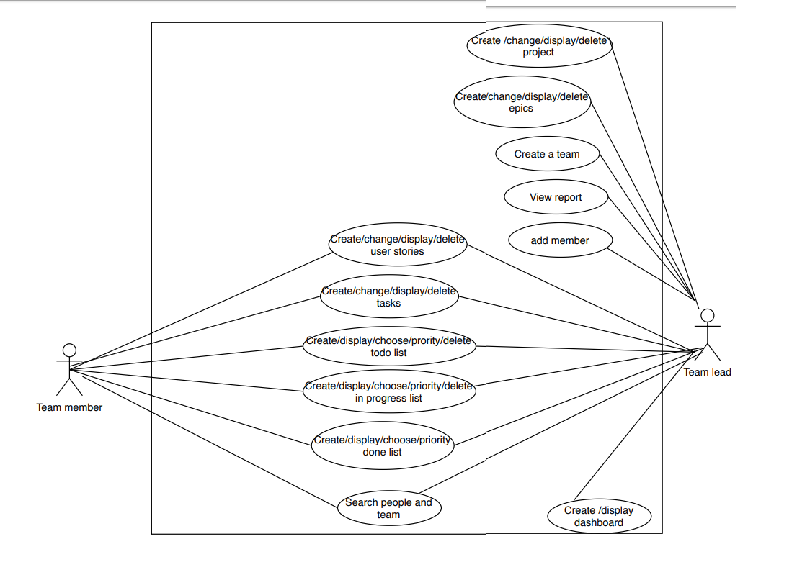

## 3.3. Glossory

• Agile software development is a set of fundamental principles about how software should be developed based on an agile way of working in contrast to previous heavy-handed software development methodologies

• Aggregate planning is an operational activity which does an aggregate plan for the production process, in advance of 2 to 18 months, to give an idea to management as to what quantity of materials and other resources are to be procured and when, so that the total cost of operations of the organization is kept to the minimum over that period.

• Allocation is the assignment of available resources in an economic way.

• Change control is the procedures used to ensure that changes (normally, but not necessarily, to IT systems) are introduced in a controlled and coordinated manner. Change control is a major aspect of the broader discipline of change management.

• Change management is a field of management focused on organizational changes. It aims to ensure that methods and procedures are used for efficient and prompt handling of all changes to controlled IT infrastructure, in order to minimize the number and impact of any related incidents upon service.

• Case study is a research method which involves an in-depth, longitudinal examination of a single instance or event: a case. They provide a systematic way of looking at events, collecting data, analyzing information, and reporting the results.

• Critical path method (CPM) is a mathematically based modeling technique for scheduling a set of project activities, used in project management.

• Critical chain project management (CCPM) is a method of planning and managing projects that puts more emphasis on the resources required to execute project tasks.

• Costs in economics, business, and accounting are the value of money that has been used up to produce something, and hence is not available for use anymore. In business, the cost may be one of acquisition, in which case the amount of money expended to acquire it is counted as cost.

• Cost engineering is the area of engineering practice where engineering judgment and experience are used in the application of scientific principles and techniques.

• Enterprise modeling is the process of understanding an enterprise business and improving its performance through creation of enterprise models. This includes the modelling of the relevant business domain (usually relatively stable), business processes (usually more volatile), and Information technology.

• Extreme project management (XPM) refers to a method of managing very complex and very uncertain projects.

• Gantt chart is a type of bar chart that illustrates a project schedule. It illustrates the start and finish dates of the terminal elements and summary elements of a project. Terminal elements and summary elements comprise the work breakdown structure of the project.

• Goal or objective consists of a projected state of affairs which a person or a system plans or intends to achieve or bring about — a personal or organizational desired end-point in some sort of assumed development. Many people endeavor to reach goals within a finite time by setting deadlines

• Goal setting involves establishing specific, measurable and time targeted objectives

• Graphical Evaluation and Review Technique (GERT) is a network analysis technique that allows probabilistic treatment of both network logic and activity duration estimated.

• Management in business and human organization activity is simply the act of getting people together to accomplish desired goals. Management comprises planning, organizing, staffing, leading or directing, and controlling an organization (a group of one or more people or entities) or effort for the purpose of accomplishing a goal.

• Management process is a process of planning and controlling the performance or execution of any type of activity.

• Management science (MS), is the discipline of using mathematical modeling and other analytical methods, to help make better business management decisions.

• Megaproject is an extremely large-scale investment project.

• Milestones are tools used in project management to mark specific points along a project timeline.

• Planning in organizations and public policy is both the organizational process of creating and maintaining a plan; and the psychological process of thinking about the activities required to create a desired goal on some scale.

• Portfolio in finance is an appropriate mix of or collection of investments held by an institution or a private individual.

• PRINCE2 : PRINCE2 is a project management methodology. The planning, monitoring and control of all aspects of the project and the motivation of all those involved in it to achieve the project objectives on time and to the specified cost, quality and performance.

• Process is an ongoing collection of activities, with an inputs, outputs and the energy required to transform inputs to outputs.

• Process architecture is the structural design of general process systems and applies to fields such as computers (software, hardware, networks, etc.), business processes (enterprise architecture, policy and procedures, logistics, project management, etc.), and any other process system of varying degrees of complexity.

• Process management is the ensemble of activities of planning and monitoring the performance of a process, especially in the sense of business process, often confused with reengineering.

• Product breakdown structure (PBS) in project management is an exhaustive, hierarchical tree structure of components that make up an item, arranged in whole-part relationship.

• Product description in project management is a structured format of presenting information about a project product

• Program Evaluation and Review Technique (PERT) is a statistical tool, used in project management, designed to analyze and represent the tasks involved in completing a given project.

• Program Management is the process of managing multiple ongoing inter-dependent projects. An example would be that of designing, manufacturing and providing support infrastructure for an automobile manufacturer.

• Project : A temporary endeavor undertaken to create a unique product, service, or result.

• Project accounting Is the practice of creating financial reports specifically designed to track the financial progress of projects, which can then be used by managers to aid project management.

• Project charter is a statement of the scope, objectives, and participants in a project.

• Project Cost Management A method of managing a project in real-time from the estimating stage to project control; through the use of technology cost, schedule and productivity is monitored.

• Project management : The complete set of tasks, techniques, tools applied during project execution

• Project Management Body of Knowledge (PMBOK) : The sum of knowledge within the profession of project management that is standardized by ISO.

• Project management office: The Project management office in a business or professional enterprise is the department or group that defines and maintains the standards of process, generally related to project management, within the organization. The PMO strives to standardize and introduce economies of repetition in the execution of projects. The PMO is the source of documentation, guidance and metrics on the practice of project management and execution.

• Project management process is the management process of planning and controlling the performance or execution of a project.

• Project Management Professional is a certificated professional in project management.

• Project Management Simulators are computer-based tools used in project management training programs. Usually, project management simulation is a group exercise. The computer-based simulation is an interactive learning activity.

• Project management software is a type of software, including scheduling, cost control and budget management, resource allocation, collaboration software, communication, quality management and documentation or administration systems, which are used to deal with the complexity of large projects.

• Project Management Triangle is a model of the constraints of project management.

• Project manager : professional in the field of project management. Project managers can have the responsibility of the planning, execution, and closing of any project, typically relating to construction industry, architecture, computer networking, telecommunications or software development.

• Project network is a graph (flow chart) depicting the sequence in which a project's terminal elements are to be completed by showing terminal elements and their dependencies.

• Project plan is a formal, approved document used to guide both project execution and project control. The primary uses of the project plan are to document planning assumptions and decisions, facilitate communication among stakeholders, and document approved scope, cost, and schedule baselines. A project plan may be summary or detailed.

• Project planning is part of project management, which relates to the use of schedules such as Gantt charts to plan and subsequently report progress within the project environment.

• Project stakeholders are those entities within or without an organization which sponsor a project or, have an interest or a gain upon a successful completion of a project.

• Project team is the management team leading the project, and provide services to the project. Projects often bring together a variety number of problems. Stakeholders have important issues with others.

• Proport refers to the combination of the unique skills of an organisation's members for collective advantage.

• Risk is the precise probability of specific eventualities.

• Risk management is a management specialism aiming to reduce different risks related to a preselected domain to the level accepted by society. It may refer to numerous types of threats caused by environment, technology, humans, organizations and politics.

• Release Ship with confidence and sanity knowing the information you have is always up-to-date.

• Report Improve team performance based on real-time, visual data that your team can put to use.

• Task is part of a set of actions which accomplish a job, problem or assignment.

• Tasks in project management are activity that needs to be accomplished within a defined period of time.

• Task analysis is the analysis or a breakdown of exactly how a task is accomplished, such as what sub-tasks are required

• Track Prioritize and discuss your team’s work in full context with complete visibility.

• Time limit is a narrow field of time, or a particular point in time, by which an objective or task must be accomplished.

Timeline is a graphical representation of a chronological sequence of events, also referred to as a chronology. It can also mean a schedule of activities, such as a timetable.

## 3.4. Supplementary

3.4.1. Function

Team Leader: This role use the following features such as Create, Change, Display, Delete projects; Create, Change, Display, Delete Epics; Create a team; View Report; Add Member; Create, Change, Display, Delete user stories; Create, Change, Display, Delete tasks; Create, Change, Display, Delete To do List; Create, Change, Display, Delete In progress List; Create, Change, Display, Delete Done List; Search People and Team; Create, display dashboard.

Team Member: This role use the following features such as Create, Change, Display, Delete user stories; Create, Change, Display, Delete tasks; Create, Change, Display, Delete To do List; Create, Change, Display, Delete In progress List; Create, Change, Display, Delete Done List; Search People and Team.

3.4.2. Usability

Platform Configuration

The desktop user shall be Windows 7/8/10 compliant. This system must be used in the computer which is in standard configuration.

- Develop for Ease-of-Use

The system shall be designed for ease-of-use and shall be appropriate for a computer- literate user community with no additional training on the System. The required training time for normal users and power users to become productive at particular operations is less than 1 week.

3.4.3. Reliability

Availability: The Project Management System shall be available 24 hours a day, 7 days a week. There shall be no more than 4% down time.

Mean time to repair (MTTR):

Mean time to repair (MTTR) shall exceed less than 1 week.

3.4.4. Performance

Simultaneous Users

The system shall support up to 50 simultaneous users against the central database at any given time, and up to 50 simultaneous users against the local servers at any one time.

3.4.5 Design Contraints

- Platform Requirements

The client portion of the Project Management System shall operate on any personal computer with a 486 processor or greater. The client portion shall require less than 1 GB disk space and 1 GB RAM.

- Internet Browsers

The web-based interface for the Project Management System shall run in all browsers such as Chrome, Firefox, CocCoc and so on.

# CHAPTER 4: SYSTEM AND SOFTWARE DESIGN

## 4.1. Activity Diagram

### 4.1.1. Login Diagram

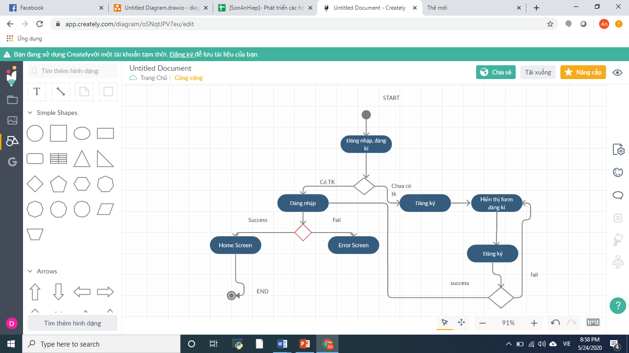

### 4.1.2. Creating Project Diagram

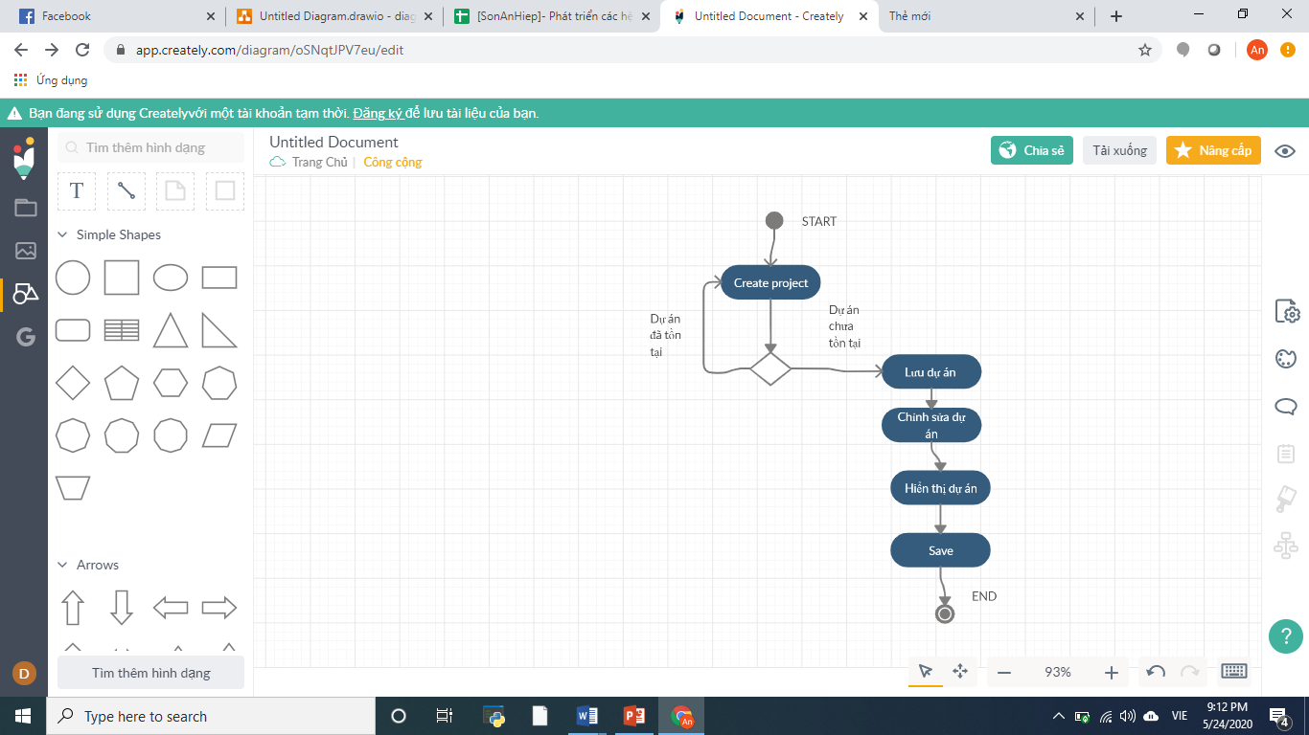

### 4.1.3. Creating a team, adding member activity diagram

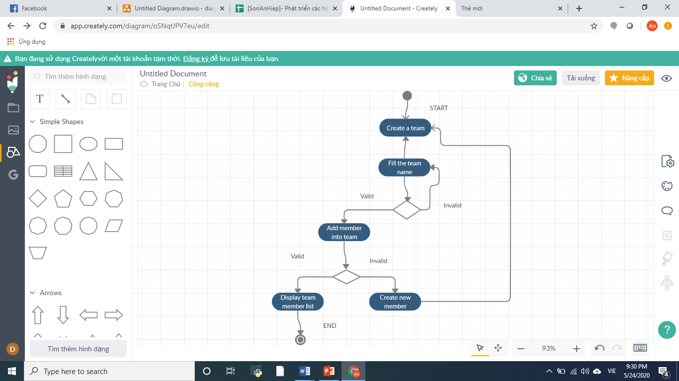

### 4.1.4. Create epics diagram

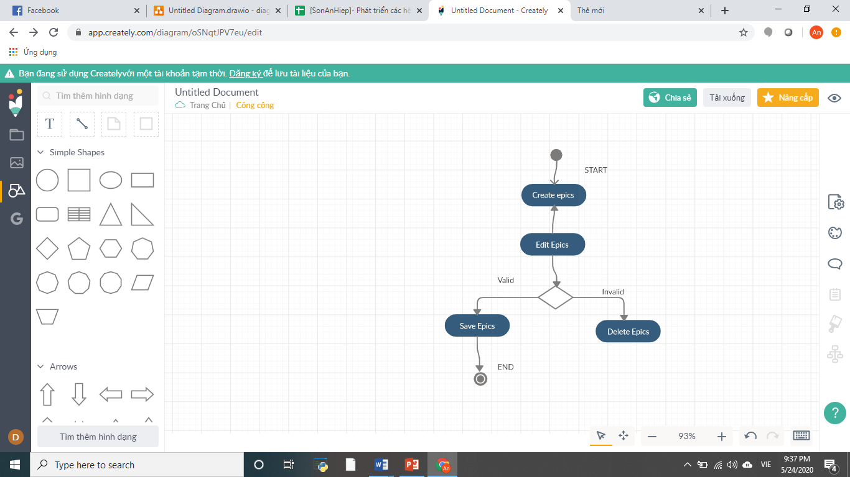

### 4.1.5. Create Task Diagram

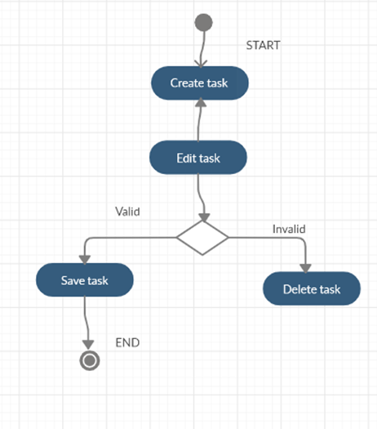

### 4.1.6. View Report Diagram

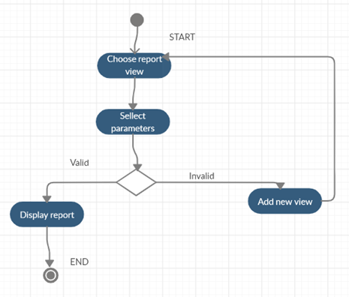

### 4.1.9. Create To-do List Diagram

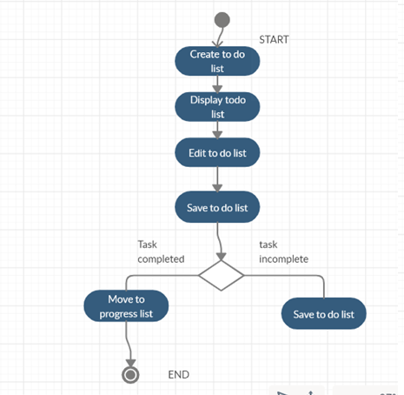

### 4.1.10. Creating Progress List Diagram

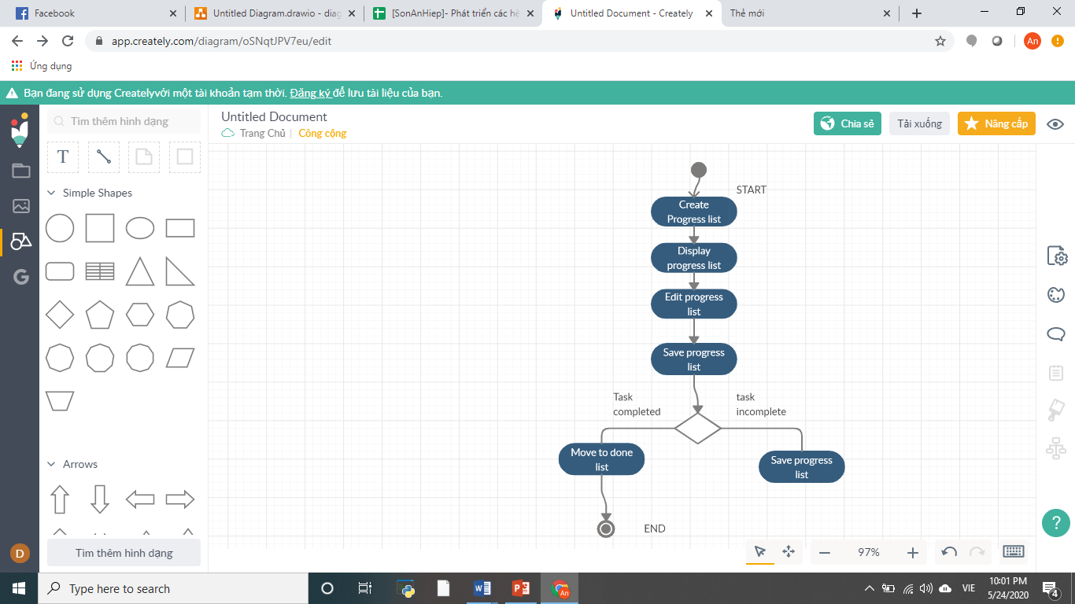

### 4.1.11. Comment Diagram

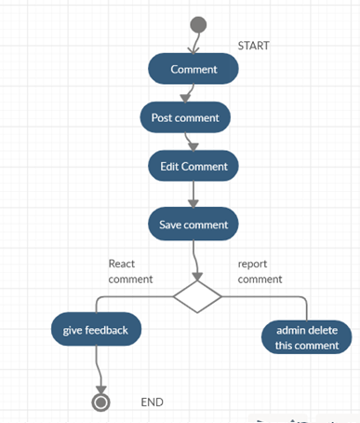

## 4.2. Class Diagram

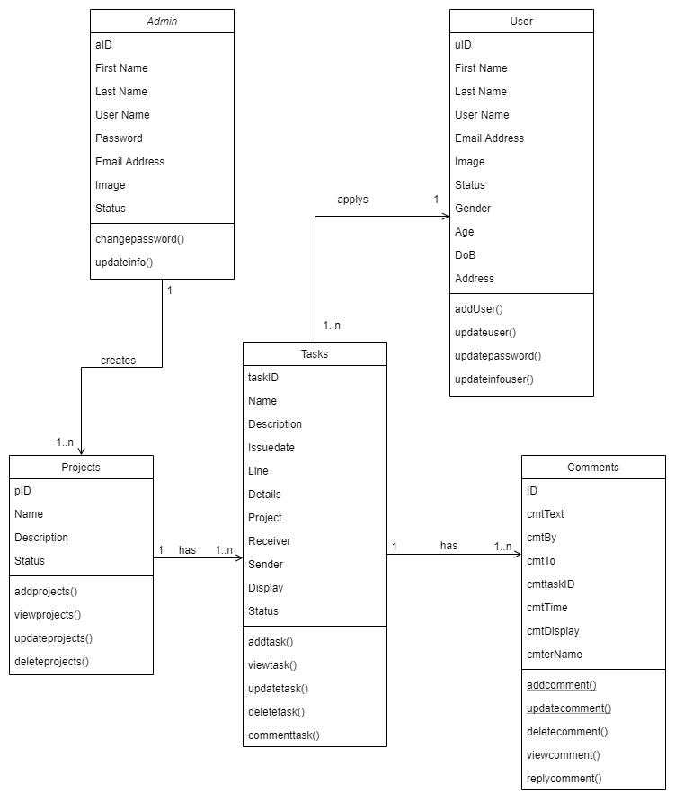

## 4.3. Entity Relationship Diagram (ERD)

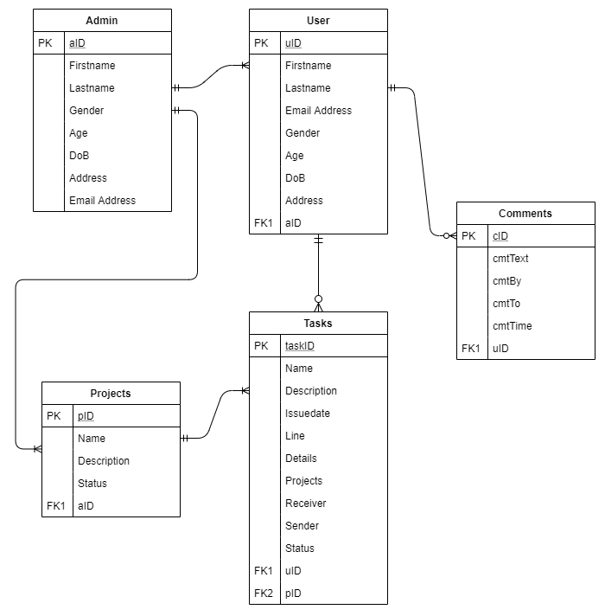

## 4.4. UI Design – Prototyping

Introduction Page Design

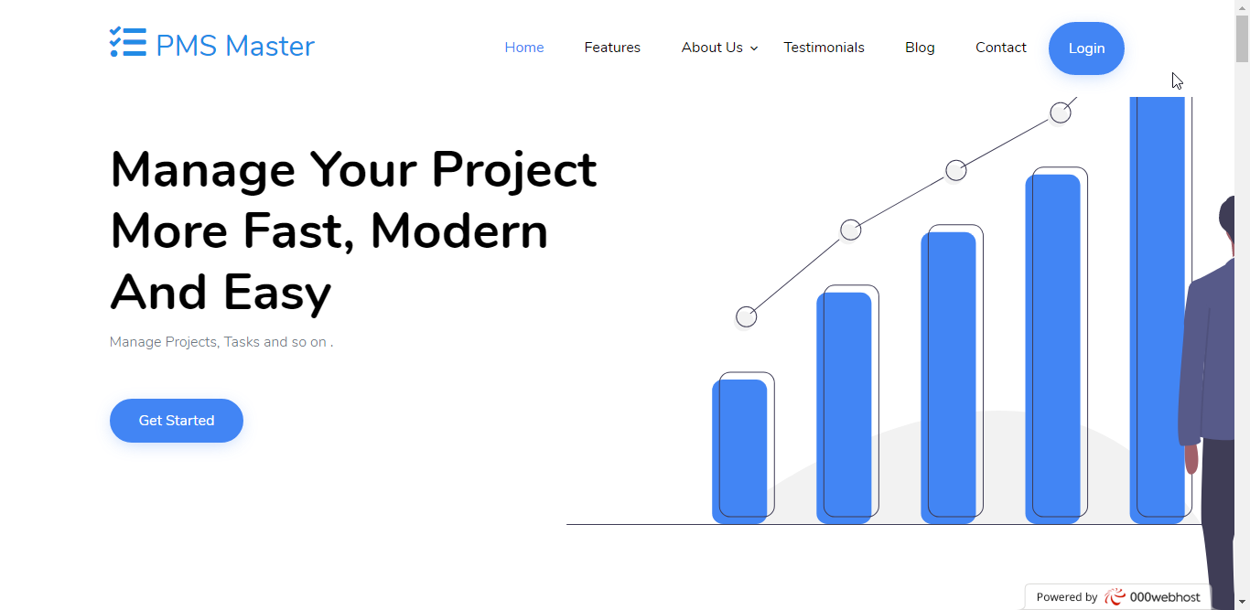

Login Page Design

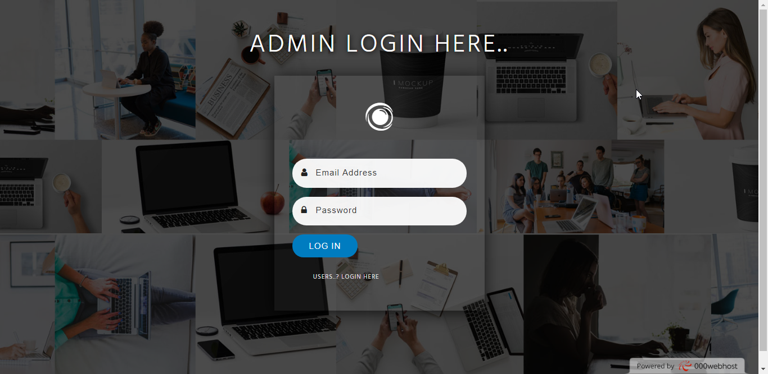

Admin Home Page Design

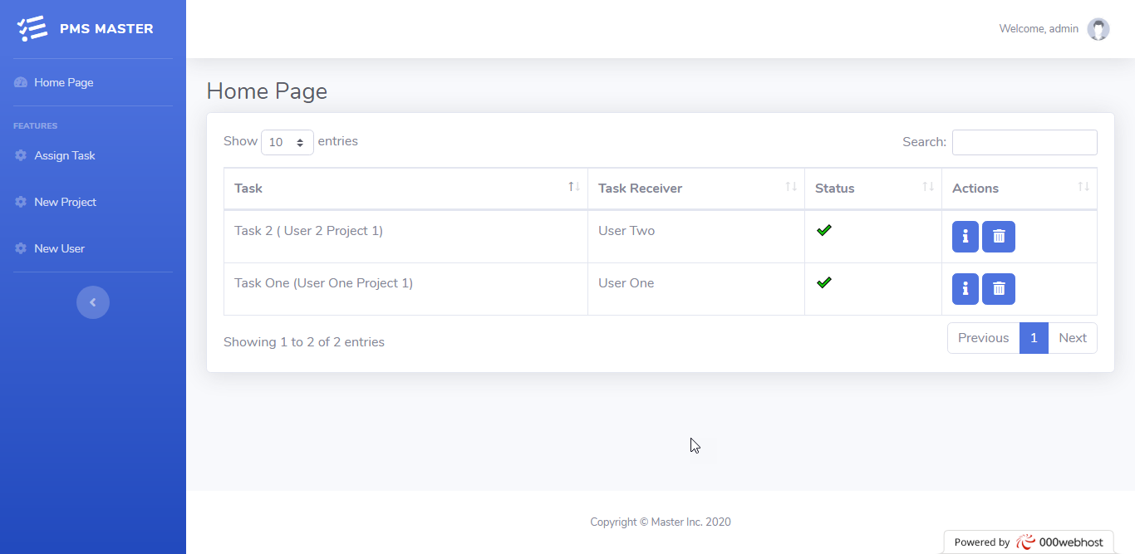

Task Detail Page Design

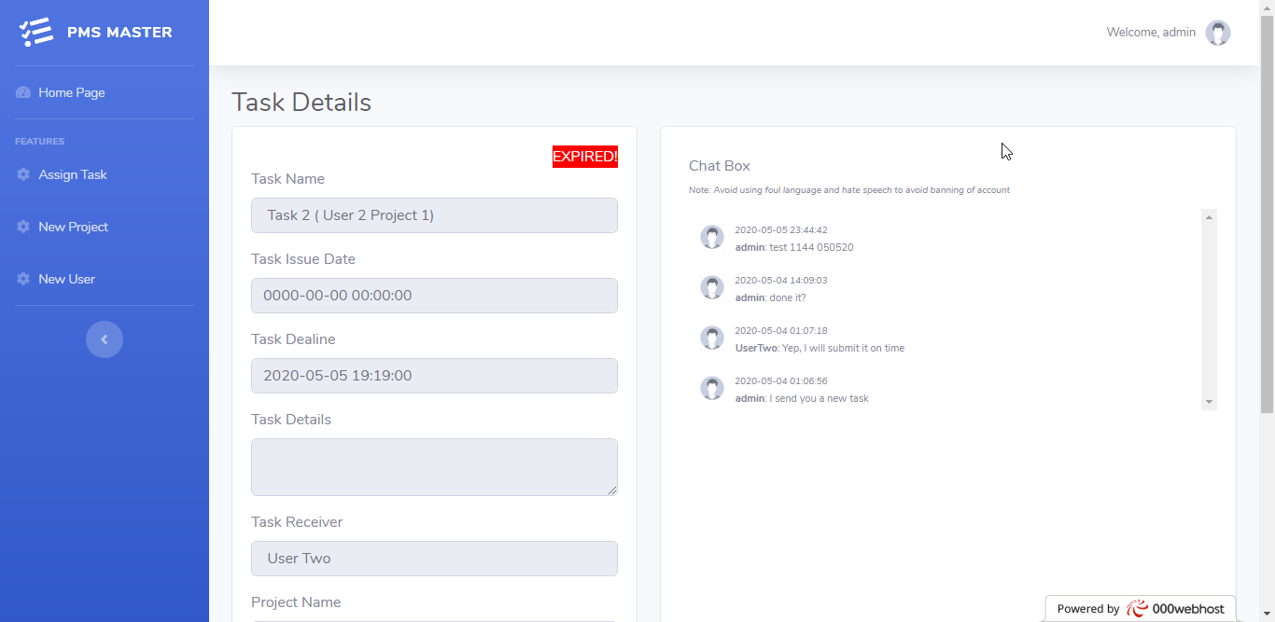

Member Assigning Page Design

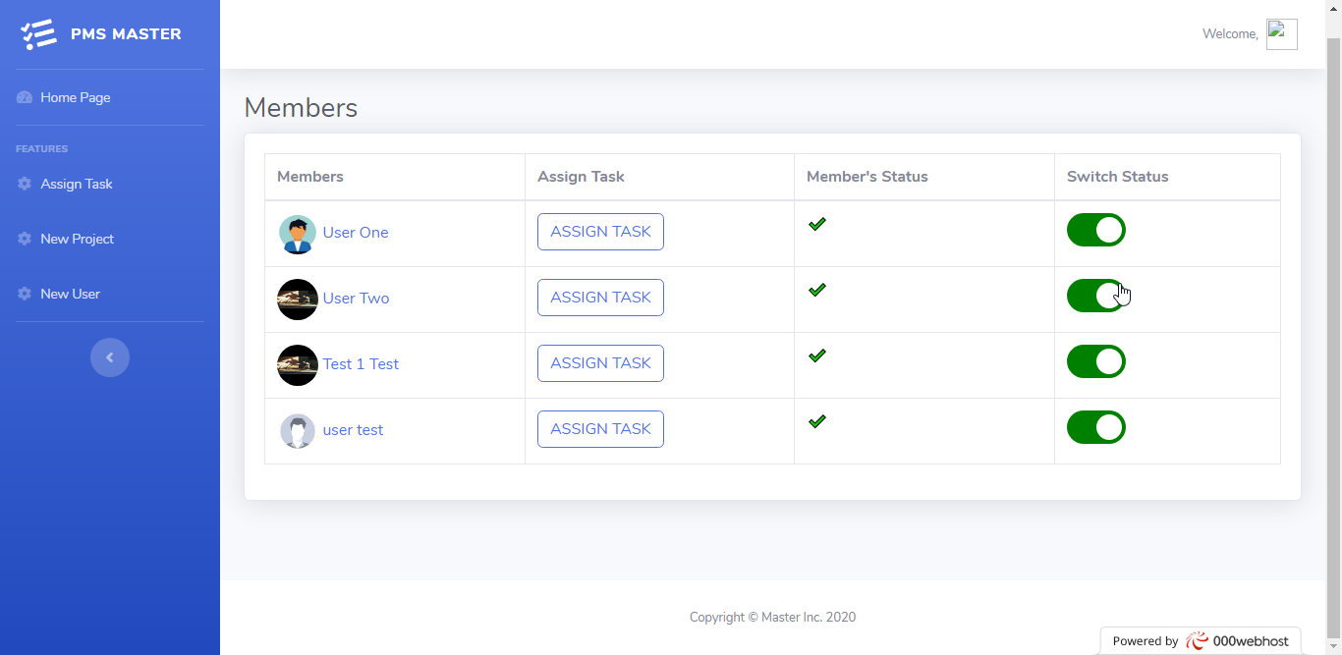

Task Assigning Page Design

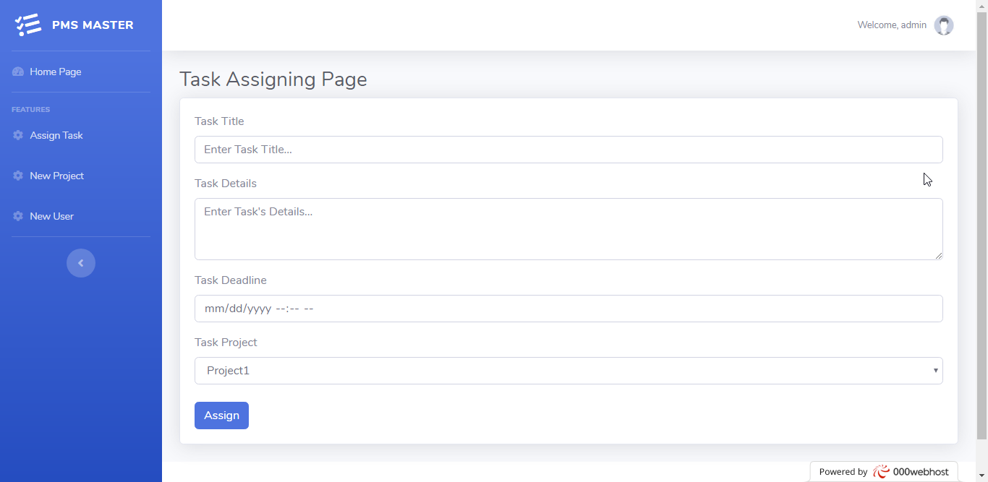

Add Project Page Design

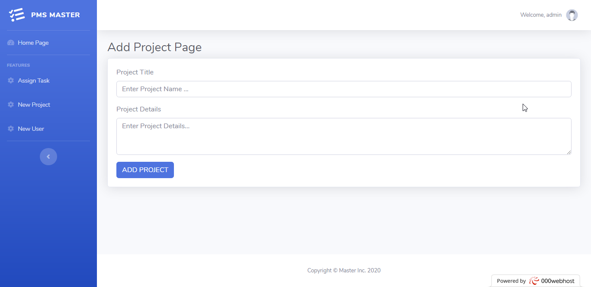

Add User Page Design

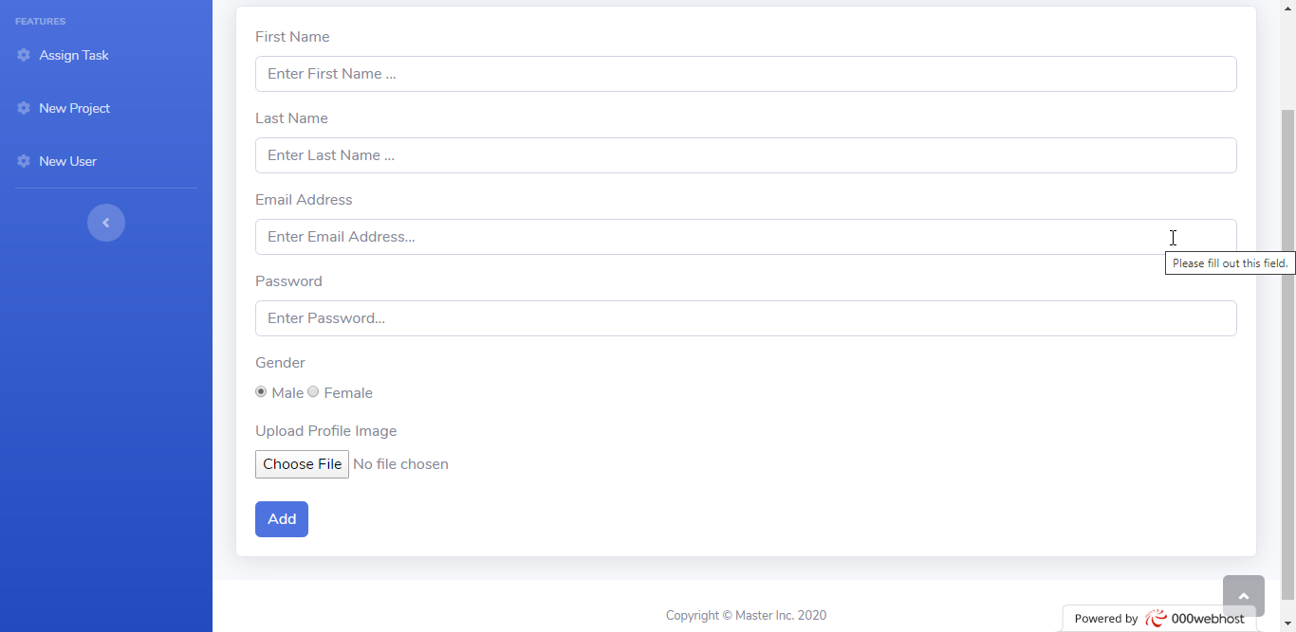

User General Information Page Design

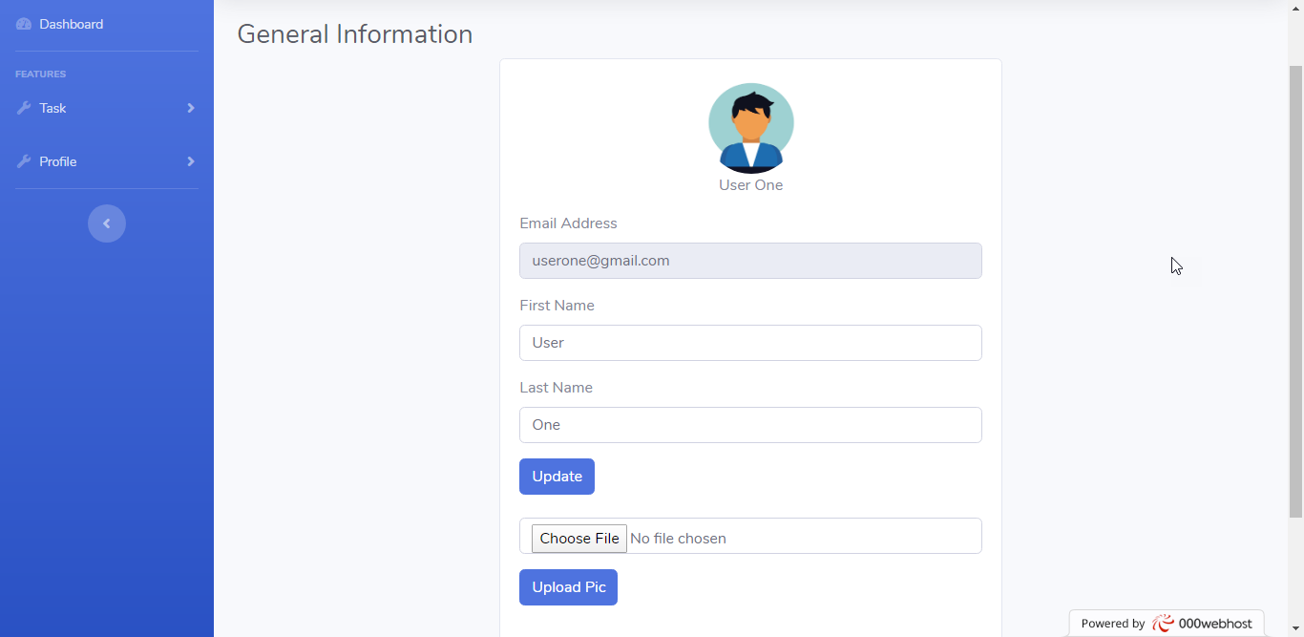

Change User Password Page Design

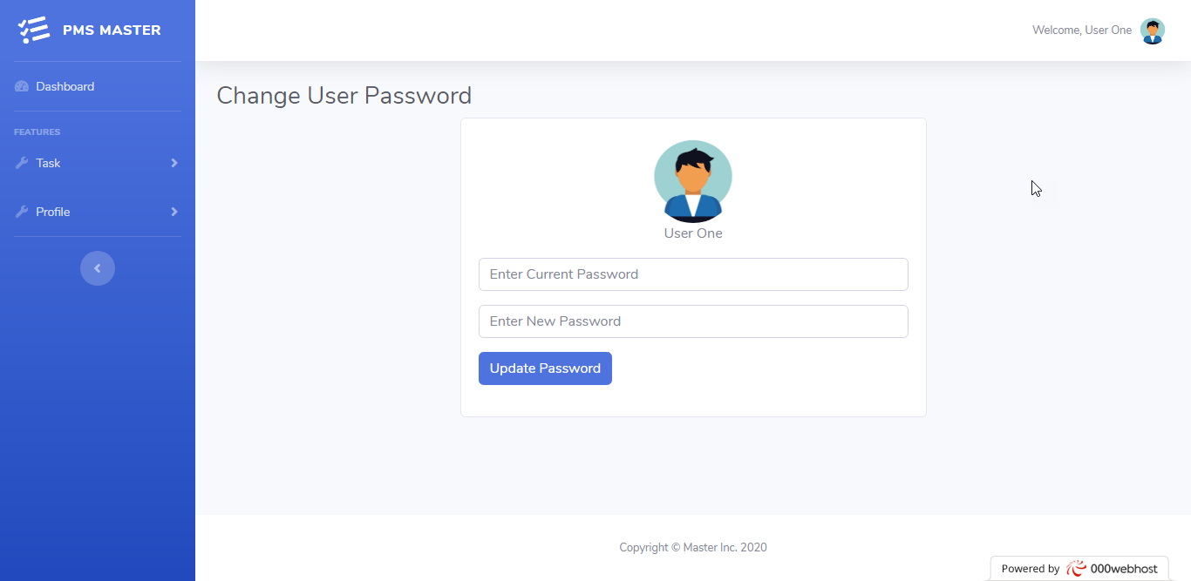

# CHAPTER 5: CONCLUSION

## 5.1. Accomplishment

Project Management Website has fully met the functions of small and medium-sized organizations: With a friendly interface, professionally integrated many useful features that best support the business activities of the business.

The project management website becomes an effective communication channel between project members.

Project management website provides the following functions:

1) Administrators -> Administrators can create new users, new projects, assign tasks to users, can turn on and off projects, users, and comments.

-> Administrators can block users -> Administrators can comment on tasks and can delete or hide tasks.

2) Members

-> Members can only view assigned tasks

-> Members are only allowed to adjust the status of assigned tasks (pending, working, completed)

-> Members can update their profile, change the password of the account.

-> Members can comment on the quest.

! There is no registration for an administrator, users can only be created by an administrator.

The administrator account is manually created in the database.

## 5.2. The limitations

+ The program has not high professionalism, not fully solved the problems that arise in the management process.

+ Function is not really complete, lacks much.

## 5.3. User development topic

With their own efforts, the project team tried to complete the topic request. Due to the limited time and capacity, the group's website is only going into the basic functions of project management.

The website development team becomes a professional project management website with the most reasonable price. We are committed to bringing you the best products with professional design styles and foreign trends, thereby serving as a platform to shape the brand as well as increase the reputation of the product and service. service you provide.

.

# REFERENCES

1. Education State University, n.d. *Project Method.* [Online]   
Available at: https://education.stateuniversity.com/pages/2337/Project-Method.html  
[Accessed 10 05 2020].

2. Guru99, n.d. *Agile Methodology & Model: Guide for Software Development & Testing.* [Online]   
Available at: https://www.guru99.com/agile-scrum-extreme-testing.html  
[Accessed 20 5 2020].

3. Interaction Design Foundation, n.d. *User Experience (UX) Design.* [Online]   
Available at: https://www.interaction-design.org/literature/topics/ux-design  
[Accessed 10 5 2020].